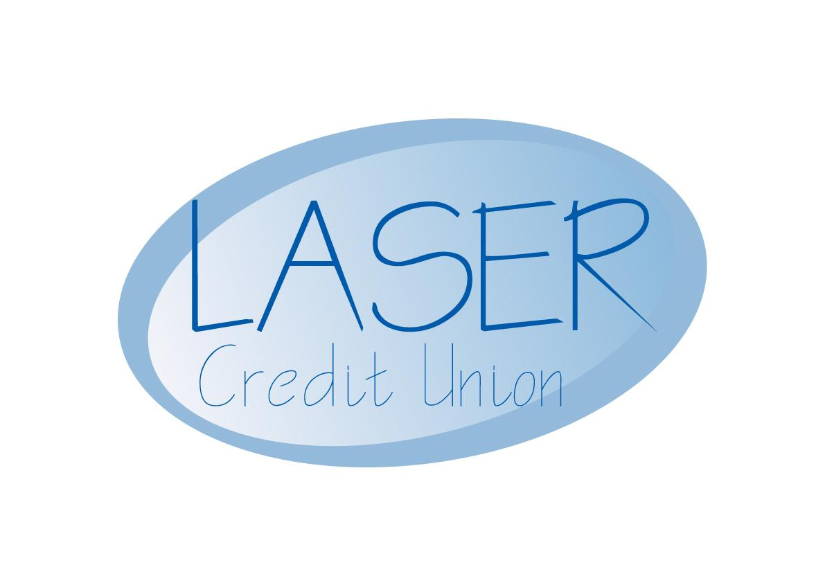
LASER Credit Union Ltd
Units 9&10
The Old Town Hall
Rotherham S60 1QX
Tel: 01709 836500
Fax: 01709 835800
Email: enquiries@lasercu.org.uk
Website: www.lasercu.org.uk

Notice of Annual General Meeting

Dear Member, this is to let you know that LASER Credit Union’s Annual General Meeting will be held on

Wednesday 16 March 2016 at 3 p.m.

At the LASER Office,

Units 9 & 10

The Old Town Hall

Rotherham

S60 1QX

LASER Credit Union Ltd is authorised by the Prudential Regulation Authority and regulated by the Financial Conduct Authority and the Prudential Regulation Authority. FCA Registration number 216632. LASER Credit Union Ltd is a member of the Financial Services Compensation Scheme and the Financial Ombudsman Service.

Any member is welcome to attend the AGM, and it is a good opportunity for you to meet the board members and have your say on the running of the organisation.

The main business of the meeting is to inform members of how LASER is doing financially, and we will present the 2014/15 accounts. We also need to appoint an auditor for the current financial year and to decide the annual dividend.

The board will make a recommendation regarding dividend for the year 2014/15, and members will be able to comment on and vote on the proposal.

One member of the board is standing down at the AGM, having made a valuable contribution to running the organisation over a number of years, and two directors who have completed their three-year term have indicated their willingness to stand again for election. We have also taken on a new Supervisor during the year and you will be asked to elect him (or otherwise, as you decide). Directors who have not yet completed their term have indicated their willingness to carry on serving, and do not need re-election.

Any member who wishes to stand for election to the board or has any particular issue they would like to be discussed at the meeting please let the office know in writing at least 48 hours before the meeting.

Notice of change to the Premier Savings Account

We have reviewed the interest rate on the Premier Savings Account and have made the decision to reduce the rate in line with current market pricing.

The interest rate on the Premier Savings Account will move from 3% to 2% with effect from 1st April 2016. Interest will continue to be paid without deduction of tax.

There is no other change to the terms and conditions of the Premier Savings Account and your savings continue to be protected by the Financial Services Compensation Scheme.

Stuart Cunningham

Secretary

LASER Credit Union

